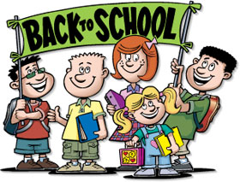
Hello 4th Graders, August 2019

Mr. McVetty and Ms. Marro (rhymes with tomorrow) will be your new 4th grade teachers at Lisbon Regional School! We are so excited to meet all of our students and be a part of this wonderful community!
We hope you are having a fantastic summer! We definitely are, but busy getting our classrooms ready! On the back of this letter you will find a list of supplies, if possible, needed for the classroom.
We would like to get to know a little bit about each of our students before the start of school on August 26th. Please feel free to send us an email at: almarr@lisbon.k12.nh.us and almcve@lisbon.k12.nh.us and let us know something about you.
We can’t wait to meet each and every one of you!

Enjoy the rest of your summer vacation,
Mr. McVetty and Ms. Marro

Supply list: If possible, please bring the following items for the school year.
- 2 or 3 regular pencils and erasers (you will need more later in the school year)
- A glue stick
- 1 1/2” or 2” 3 ring binder
- and if possible, a container of Lysol/Clorox wipes and a box of tissues to donate to the class (to wipe down desks and door knobs)

You may choose to bring: colored pencils, and a pencil box, but please DO NOT bring fidget spinners or any other type of fidget toy to school.
Enjoy the rest of your summer, play outside as much as possible and we will see you August 26th!

Mr. McVetty and Ms. Marro

